- As we will see in this chapter, it is important to consider the electrical properties of neurons as they relate to specific geometries

- One of the simplest geometrical shapes approximated by some parts of a neuron is a cylinder. The cylinder has a
conductive core surrounded by an outer shell or membrane that has different electrical properties from its core. Many of the simplifications we will make will be to allow parts of a neuron, such as its axon or pieces of its dendrites, to be represented by such cylinders.

-The mathematics of cylinders in which current flows down the center and across the sides (also called core conductors or electrical cables) has been around for many years, dating back in some cases to the first transatlantic cable used to
transmit telegraphy.

-Linear cable or core conductor theory and is used to investigate the passive electrotonic spread of electrical signals in dendrites (also called electrotonus).
- Electrotonic is a rather arcane term that is used to describe passive electrical signals, that is, signals (current or voltage) that are not influenced by the voltage-dependent properties
of the membrane.

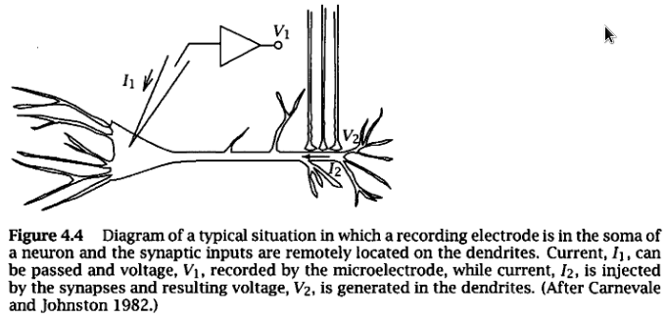

- It will become obvious that this theory is too simple to explain the complexities of dendrites, but at least it is a good starting point. In particular, many dendrites have voltage-gated channels at different locations, and these channels will influence the integrative properties of the neuron in important ways.

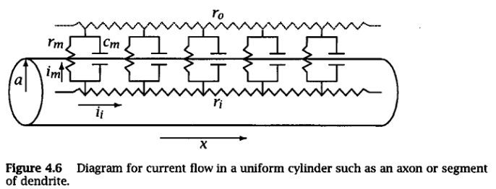
- First, we will discuss cable properties in general and derive equations that will be applied to a number of different physical situations. Second, we will apply the theory to infinite and semi-infinite cables. This situation is particularly applicable to long axons. Third, we will apply the theory to finite cables and then to finite cables with lumped soma. This
situation represents the application of the theory to dendrites, and we will show how a complex dendritic tree can be reduced to a simpler cable structure. After deriving the appropriate equations for each situation, we will apply them to investigate how cable properties influence synaptic inputs.

- In addition to the parameters of membrane resistance and capacitance, we have added the resistance of the cytoplasm, гi, the resistance of the extracellular space, r0 , and distance along the cylinder, x. The extracellular space will be considered isopotential for the sake of simplicity (i.e., r0 = 0).
- Current injected into the cylinder will, by Kirchhoff s current law, flow both across the membrane (im) and along the inside of the cylinder or cable (if).

- Assumptions:
1. The membrane parameters are assumed to be linear and uniform throughout. That is, r_m, r_i, and cm are constants, they are the same in all parts of the neuron, and they are not dependent on the membrane potential (i.e., passive).
2. We assume that current flow is along a single spatial dimension, x, the distance along the cable. Radial current is therefore assumed to
be 0.
3. As mentioned above, we assume for convenience that the extracellular resistance, r0 , is 0.
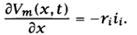

- This is just Ohm's law (the decrease in Vm with distance is equal to the current times the resistance). The negative sign denotes that voltage
decreases with increasing x (negative slope).
- Some of i_i, however, "leaks" out across the membrane (analogous to a leaky hose) through r m and сm ,so that i_i is not constant with distance. The decrease in i_i with distance
is equal to the amount of current that flows across the membrane or im. This follows from Kirchhoff's current law and is stated mathematically as
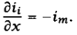

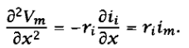

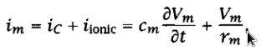
Tenemos del capitulo 3:

